Acupuncture for Infertility: Nurturing Balance and Enhancing Fertility Naturally
3 min read
Struggling with infertility can be one of life’s most emotional and challenging journeys. Whether you’re preparing for conception naturally or undergoing fertility treatments such as IVF or IUI, finding balance in your body and mind is key. Many individuals and couples are turning to acupuncture for infertility as a safe, natural, and holistic approach to support reproductive health and improve fertility outcomes.
Rooted in Traditional Chinese Medicine (TCM), acupuncture works to restore harmony in the body by regulating hormones, improving blood flow to the reproductive organs, and reducing stress three key factors in successful conception.
In this article, we’ll explore how acupuncture can help with infertility, what to expect during treatment, and how to enhance your fertility journey through supportive lifestyle habits.

What Is Acupuncture for Infertility?
Acupuncture involves inserting ultra-fine, sterile needles into specific points on the body called acupoints. These points correspond to energy channels (meridians) that influence organ function, hormonal balance, and circulation.
When it comes to fertility, acupuncture aims to:
- Regulate menstrual cycles and ovulation
- Improve blood flow to the uterus and ovaries
- Enhance egg and sperm quality
- Balance reproductive hormones naturally
- Support implantation and early pregnancy
- Reduce stress and anxiety, which can impact conception
Unlike many conventional treatments that focus solely on the reproductive organs, acupuncture takes a whole-body approach addressing the root cause of imbalance rather than just the symptoms.
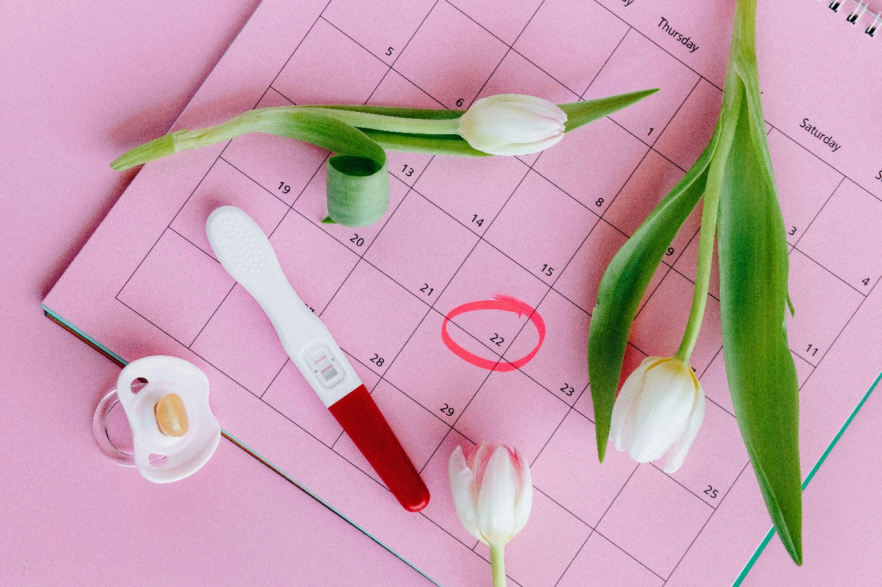

Common Fertility Challenges We Treat
Acupuncture may be beneficial for a wide range of reproductive concerns, including:
- Irregular or absent periods (amenorrhea)
- Polycystic Ovarian Syndrome (PCOS)
- Endometriosis
- Unexplained infertility
- Low ovarian reserve
- Recurrent miscarriage
- Luteal phase defect (short cycles)
- Male infertility (low sperm count, motility, or morphology issues)
During your consultation, we’ll discuss your medical history, menstrual patterns, stress levels, and lifestyle to create a personalized fertility plan.

What to Expect During a Session
If you’re new to acupuncture, here’s what a typical fertility session looks like:
Initial Consultation: We’ll discuss your fertility goals, menstrual health, and any prior fertility treatments.
Treatment Plan: For optimal results, treatments are usually done once or twice weekly, depending on your cycle phase and fertility plan.
During Treatment: You’ll rest comfortably while fine needles are gently inserted into acupoints on the lower abdomen, legs, and sometimes ears or wrists. Most patients find the sessions deeply relaxing.
Integration with IVF/IUI: Acupuncture can be used to enhance outcomes before and after embryo transfer, improving uterine receptivity and reducing stress.
Aftercare: You may feel calm and balanced after treatment. Many patients report improved sleep, better moods, and more regular menstrual cycles after several sessions.

Benefits Supported by Research
Scientific research continues to affirm acupuncture’s value in fertility care:
- A 2023 Fertility and Sterility review found acupuncture improves IVF success rates and endometrial receptivity.
- A study in Human Reproduction showed acupuncture helps regulate hormone levels, especially LH and FSH, improving ovulation frequency.
- Clinical experience shows acupuncture can reduce anxiety and promote hormonal balance, both essential for successful conception.

Lifestyle Tips to Support Fertility
To get the most out of your acupuncture sessions, combine them with simple supportive habits:
- Eat for Fertility: Choose whole foods, healthy fats, and iron-rich greens. Avoid excessive caffeine and alcohol.
- Manage Stress: Practice mindfulness, yoga, or breathing exercises to keep cortisol levels balanced.
- Prioritize Sleep: Quality rest supports hormone regulation and ovulation.
- Stay Consistent: Acupuncture works best with regular sessions over several menstrual cycles.

Acupuncture offers a nurturing, effective, and holistic path toward conception. By balancing hormones, improving circulation, and calming the mind, it creates an optimal environment for natural or assisted fertility.
If you’re based in Sandton, Midrand, or nearby areas, and are ready to explore natural ways to enhance fertility, our clinic is here to support your journey.
📅 Book an appointment or contact us at 064 022 5386
Rebaone Monama
Registered Acupuncturist | African Centre of Chinese Medicine and Acupuncture
AHPCSA Registered

