Acupuncture for Back Pain: A Gentle Path to Lasting Relief
3 min read
Back pain is one of the most common health concerns worldwide — whether it’s a dull ache from sitting too long, tightness after exercise, or sharp pain that limits your movement. For many people, this discomfort becomes a daily struggle that affects sleep, focus, and overall wellbeing.
If you’ve been searching for “acupuncture for back pain near me,” you’re not alone — and you might be on the right track. Acupuncture offers a safe, natural, and effective way to relieve pain, restore mobility, and improve quality of life without relying solely on medication.
Rooted in Traditional Chinese Medicine (TCM), acupuncture views back pain not just as a structural issue, but as a sign of imbalance within the body’s energy flow. Through precise, gentle stimulation of specific acupoints, acupuncture helps reduce inflammation, relax tight muscles, and encourage the body’s natural healing response.

What Is Acupuncture for Back Pain?
Acupuncture involves inserting ultra-fine, sterile needles into specific points on the body. These points are chosen based on where your pain is located and what’s causing it.
For back pain, acupuncture may help to:
- Relieve muscle tension and spasm
- Improve blood circulation to the spine and muscles
- Reduce inflammation and nerve irritation
- Support better posture and mobility
- Alleviate stress and emotional tension that worsen pain
Acupuncture doesn’t just mask the pain — it works to address the root cause and promote long-term healing.

Common Causes of Back Pain We Treat
Back pain can develop for many reasons, and acupuncture can help with most of them, including:
- Muscle strain or overuse injuries
- Poor posture or prolonged sitting
- Herniated or bulging discs
- Sciatica (nerve pain radiating down the leg)
- Osteoarthritis or joint degeneration
- Postural imbalances
- Stress-related tension
- Sports or work-related injuries
During your consultation, we’ll identify the underlying cause and design a personalized treatment plan tailored to your lifestyle and health needs.
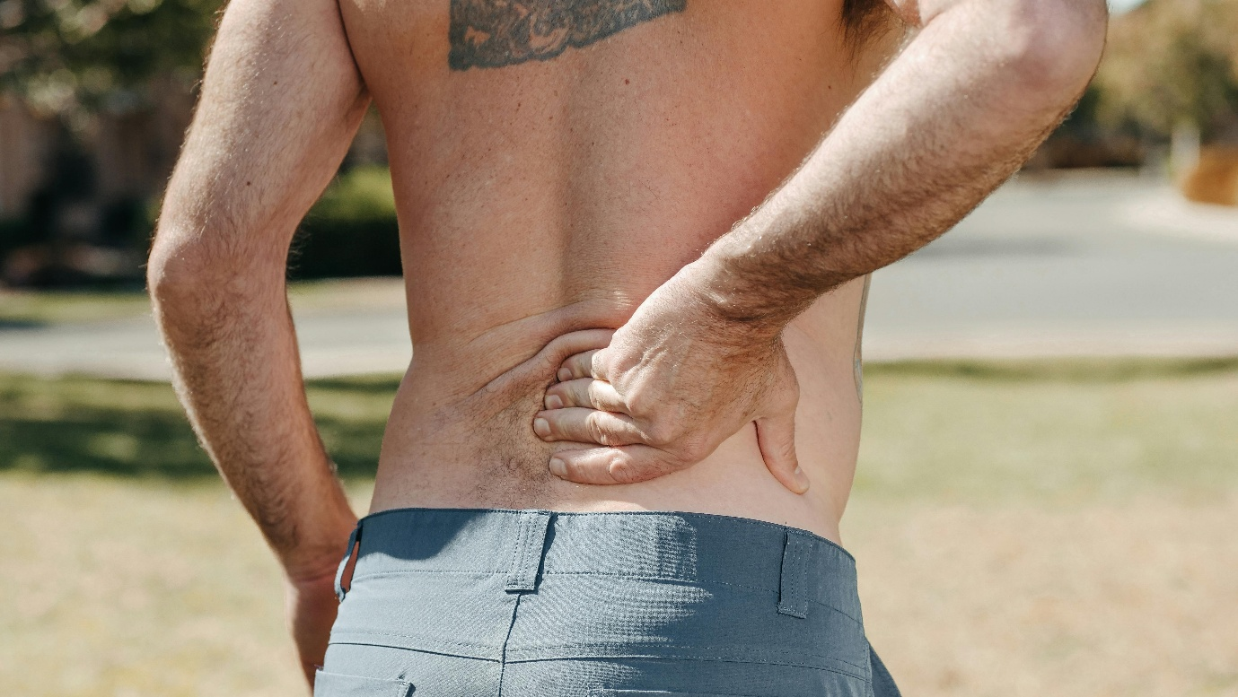

What to Expect During a Session
If you’re new to acupuncture, here’s what typically happens:
Initial Consultation: We’ll discuss your symptoms, lifestyle, posture, and any contributing factors such as stress, sleep, or exercise habits.
Treatment Plan: Most patients start with 1–2 sessions per week for the first few weeks, tapering as symptoms improve.
During Treatment: You’ll lie comfortably while fine needles are gently placed in specific acupoints — often on your back, legs, and arms. Many people feel a pleasant warmth or tingling sensation and often fall asleep during the session.
Aftercare: You may feel lighter, looser, and more mobile. Mild soreness can occur temporarily but fades quickly. Regular sessions lead to longer-lasting relief and improved strength.

Benefits Backed by Research
Clinical evidence continues to support acupuncture’s effectiveness in treating both acute and chronic back pain:
- A 2024 review in Pain Medicine found acupuncture significantly reduced pain intensity and improved physical function.
- Research in The Journal of Pain showed acupuncture outperformed standard care for chronic lower back pain.
- The National Institutes of Health (NIH) recognizes acupuncture as an effective treatment for back pain and sciatica.

Tips to Maximize Your Recovery
To get the most from your acupuncture treatments:
- Improve Your Posture: Adjust your workstation or chair to support your lower back.
- Stay Active: Light movement such as walking, stretching, or swimming keeps circulation flowing.
- Manage Stress: Mental tension often shows up as physical pain — relaxation helps healing.
- Prioritize Rest: Allow your body time to recover between sessions.
Consistency is key. Acupuncture works cumulatively, so regular treatments bring the best long-term results.

Conclusion: Move Freely, Live Comfortably
Acupuncture offers a natural, non-invasive solution for back pain relief. By addressing both physical and energetic imbalances, it helps reduce discomfort, restore flexibility, and improve overall wellbeing allowing you to move with ease again.
If you’re in Sandton, Midrand, or nearby areas and ready to find lasting relief from back pain, we’re here to help.
📅 Book an appointment or contact us at 064 022 5386
Rebaone Monama
Registered Acupuncturist | African Centre of Chinese Medicine and Acupuncture
AHPCSA Registered

