Acupuncture for Stroke Recovery: Restoring Movement, Balance, and Vitality
3 min read
A stroke can change life in an instant affecting movement, speech, balance, and independence. The journey to recovery can be long, and many patients are looking for supportive, natural therapies that can complement conventional rehabilitation. If you’ve been searching for “acupuncture for stroke recovery near me,” you may be exploring one of the most effective traditional methods for improving post-stroke healing.
Acupuncture, rooted in Traditional Chinese Medicine (TCM), is increasingly being recognized as a valuable complementary therapy in stroke rehabilitation. It works by stimulating the body’s natural healing processes, improving circulation, and helping restore nerve and muscle function.
In this article, we’ll explore how acupuncture supports recovery after stroke, what to expect during treatment, and the benefits backed by both research and clinical experience.

What Is Acupuncture for Stroke Recovery?
Acupuncture involves the gentle insertion of fine, sterile needles into specific points on the body known as acupoints. These points help activate nerve pathways, improve blood flow to the brain and muscles, and restore balance between different systems in the body.
For stroke recovery, acupuncture aims to:
- Improve muscle strength and coordination
- Enhance mobility and balance
- Reduce muscle stiffness and spasticity
- Improve speech and swallowing function
- Support emotional wellbeing and reduce anxiety
- Stimulate nerve regeneration and improve brain function
The goal isn’t just to manage symptoms — it’s to reactivate the body’s natural ability to heal and rebuild connections.
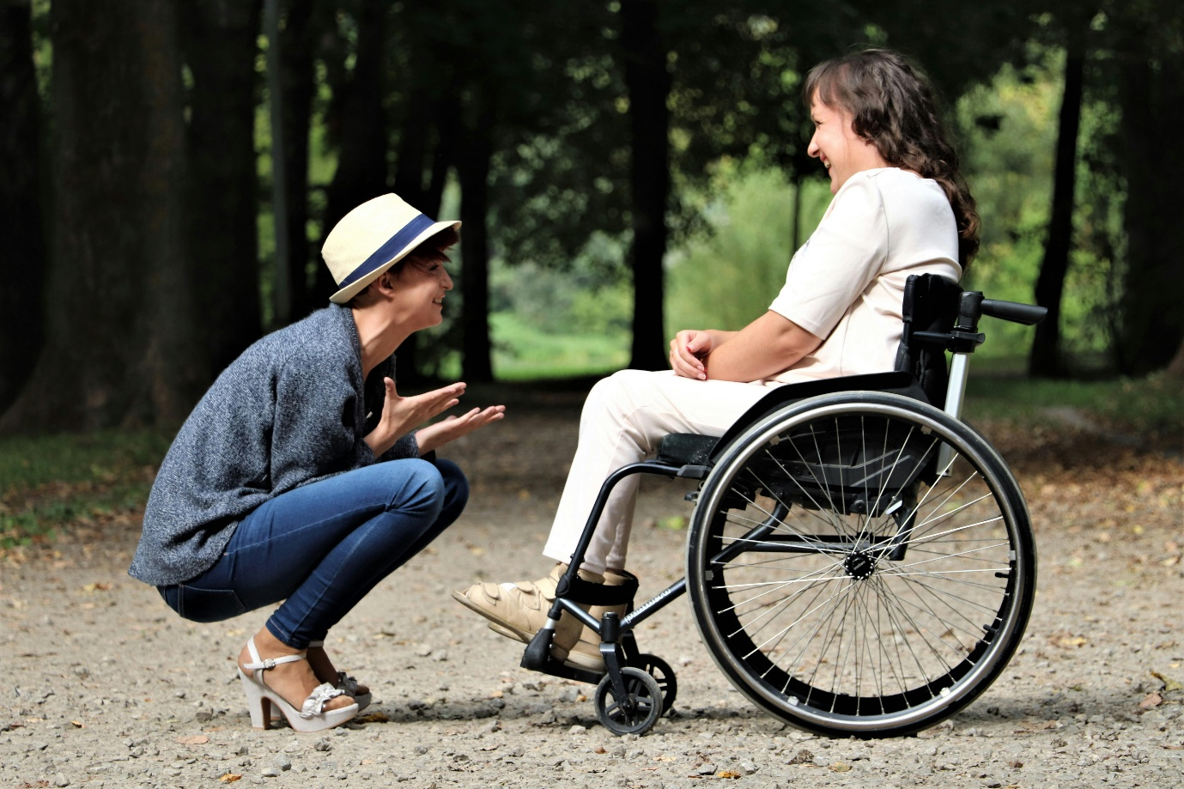

Common Post-Stroke Challenges We Address
Acupuncture can be used alongside physiotherapy and conventional medicine to support:
- Weakness or paralysis on one side of the body (hemiplegia)
- Muscle stiffness, spasms, or pain
- Difficulty with speech or swallowing
- Fatigue and low energy
- Poor circulation and slow recovery
- Emotional changes such as depression, anxiety, or frustration
During your consultation, we’ll assess your symptoms, medical history, and rehabilitation progress to tailor a treatment plan specific to your stage of recovery.

What to Expect During a Session
If you’re new to acupuncture, here’s what a typical session might look like:
Initial Consultation: We’ll discuss your stroke history, current symptoms, mobility, and any challenges with speech or muscle control.
Treatment Plan: Sessions may start at 1–3 times per week depending on the recovery phase, then taper as improvement continues.
During Treatment: You’ll lie comfortably as fine needles are placed in selected acupoints — often on the limbs, scalp, and torso. Some patients experience a mild tingling or warmth as circulation improves.
Scalp Acupuncture: This specialized technique is often used for stroke recovery, directly stimulating brain regions responsible for movement and speech.
Aftercare: You may feel relaxed or slightly tired after treatment. Gradual improvements are expected over several sessions, especially when combined with physiotherapy and movement exercises.

Benefits Supported by Research
Modern studies support the role of acupuncture in post-stroke rehabilitation:
- A 2024 review in the Frontiers in Neurology journal found acupuncture improves motor recovery and neurological function when combined with standard rehabilitation.
- A meta-analysis published in Medicine (Baltimore) reported that acupuncture significantly enhanced daily living ability and reduced disability scores in stroke patients.
- Clinical experience consistently shows that early and regular acupuncture treatments lead to faster recovery and improved long-term outcomes.

Tips to Support Your Recovery
To get the most from your acupuncture sessions:
- Stay Active: Gentle exercises recommended by your physiotherapist help retrain the brain and muscles.
- Maintain Good Nutrition: Focus on whole foods rich in omega-3s, antioxidants, and hydration.
- Stay Consistent: Acupuncture works cumulatively regular sessions yield the best outcomes.
- Balance Rest and Activity: Rest allows healing, while movement promotes circulation and recovery.
Acupuncture offers a gentle, natural, and evidence-based approach to enhance stroke recovery. By improving circulation, reducing spasticity, and reawakening the body’s healing potential, it helps patients regain mobility, confidence, and independence.
If you or a loved one are recovering from a stroke in Sandton, Midrand, or surrounding areas, our clinic provides personalized acupuncture treatments to support every stage of recovery.
📅 Book an appointment or contact us at 064 022 5386
🌐 Learn more at www.monamaacupuncture.com
Rebaone Monama
Registered Acupuncturist | African Centre of Chinese Medicine and Acupuncture
AHPCSA Registered

